EXTENDED TO NOVEMBER 15, 2024
Form 990  Department of the Treasury  Internal Revenue Service | Return of Organization Exempt From Income Tax  Under section 501(c), 527, or 4947(a)(1) of the Internal Revenue Code (except private foundations) Do not enter social security numbers on this form as it may be made public. Go to www.irs.gov/Form990 for instructions and the latest information. | OMB No. 15450047
 |  | 2023
 |  | Open to Public Inspection

A For the 2023 calendar year, or tax year beginning and ending
B Check if applicable:  I—lchange  I—I change  I—linitial  L—lreturn  Final return/ terminated  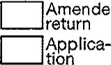  Amended  pending |  |  | C Name of organization  LEAH'S KIDS, INC. |  |  |  |  |  |  |  |  |  |  |  |  |  | D Employer identification number  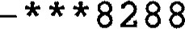
 |  |  | Doin business as LEAH ^{r} S KIDS
 |  |  | Number and street (or P.O. box if mail is not delivered to street address)  46031 239TH ST |  |  |  |  |  |  |  |  |  |  | Room/suite |  |  | E Telephone number  605-359-2270
 |  |  | City or town, state or province, country, and ZIP or foreign postal code  WENTWORTH, SD 57075 |  |  |  |  |  |  |  |  |  |  |  |  |  | G Gross receipts $ 138 , 562 .
H(a) Is this a group return
for subordinates? [ZZ]Yes [X] No
If "No," attach a list. See instructions
H c) Grou exem tion number
F Name and address of principal officer:CHAD LARSON
46031 239TH ST, WENTWORTH, SD 57075
- Tax-exem t status: 501(c) ( (insert no.) 527
- Website: WWW. LEAHSKIDS • ORG
K Form of organization: |  |  |  |  | Corporation |  |  |  | Trust |  | Association |  | Other |  | L Year of formation: 2016 M State of legal domicile: SD
Part I |  | Summary
 | 1 Briefly describe the organization's mission or most significant activities: TO HELP ORPHANS , WIDOWS AND THE
 | LESS FORTUNATE IN GUATEMALA AND BEYOND BY PROVIDING HOUSING,
 | - Check this box  - Number of voting  - Number of independent  - Total number of  - Total number of  - a Total unrelated business b Net unrelated business |  |  |  |  |  | if the organization discontinued its operations or disposed of more than 25% of its of the governing body (Part VI, line la) voting members of the governing body (Part VI, line 1 b) employed in calendar year 2023 (Part V, line 2a)  (estimate if necessary) revenue from Part VIII, column (C), line 12  taxable income from Form 990-T, Part l, line 1 1 |  |  |  |  |  |  |  |  |  |  | net  3 | assets.  7
 |  |  |  |  |  | members  individuals volunteers |  |  |  |  |  |  |  |  |  |  |  | net  3 | assets.  7
 |  |  |  |  |  |  |  |  |  |  |  |  |  |  |  |  |  | 4 | 7
 |  |  |  |  |  |  |  |  |  |  |  |  |  |  |  |  |  | 5
 |  |  |  |  |  |  |  |  |  |  |  |  |  |  |  |  |  | 6 | 0
 |  |  |  |  |  |  |  |  |  |  |  |  |  |  |  |  |  |  | o .
 |  |  |  |  |  |  |  |  |  |  |  |  |  |  |  |  |  | 7b | o .
 | - Contributions and grants (Part VI", line 1 h)  - Program service revenue (Part Vlll, line 2g)  - Investment income (Part Vtll, column (A), lines 3, 4, and 7d)  - Other revenue (Part VI", column (A), lines 5, 6d, 8c, 9c, IOC, and Ile)  - Total revenue - add lines 8 throu h 1 1 muste ual Part VIII, column A, line 12 |  |  |  |  |  |  |  |  |  |  |  |  |  |  | Prior Year |  |  | Current Year
 |  |  |  |  |  |  |  |  |  |  |  |  |  |  |  | 72 , 892 |  |  | 138 , 504
 |  |  |  |  |  |  |  |  |  |  |  |  |  |  |  | 0 . |  |  | 0 .
 |  |  |  |  |  |  |  |  |  |  |  |  |  |  |  | 15 . |  |  | 58 .
 |  |  |  |  |  |  |  |  |  |  |  |  |  |  |  | o . |  |  | 0 .
 |  |  |  |  |  |  |  |  |  |  |  |  |  |  |  | 72 , 907 |  |  | 138 , 562
(.0 | - Grants and similar amounts paid (Part IX, column (A), lines 1-3)  - Benefits paid to or for members (Part IX, column (A), line 4)  - Salaries, other compensation, employee benefits (Part IX, column (A), lines 5-10)  16a Professional fundraising fees (Part column (A), line 1 1 e) b Total fundraising expenses (Part column (D), line 25) o .  - Other expenses (Part 'X, column (A), lines 1 1 a-1 1 d, 1 If-24e)  - Total expenses. Add lines 13-17 (must equal Part IX, column (A), line 25)  - Revenue less expenses, Subtract line 18 from line 12 |  |  |  |  |  |  |  |  |  |  |  |  |  |  | o . |  |  | o .
(.0 |  |  |  |  |  |  |  |  |  |  |  |  |  |  |  | o . |  |  | o .
(.0 |  |  |  |  |  |  |  |  |  |  |  |  |  |  |  | o . |  |  | o .
(.0 |  |  |  |  |  |  |  |  |  |  |  |  |  |  |  | o . |  |  | o .
(.0 |  |  |  |  |  |  |  |  |  |  |  |  |  |  |  | 75 , 546 |  |  | 136 , 163
(.0 |  |  |  |  |  |  |  |  |  |  |  |  |  |  |  | 75 , 546 |  |  | 136 , 163
(.0 |  |  |  |  |  |  |  |  |  |  |  |  |  |  |  | -2 , 639 |  |  | 2 , 399
 | - Total assets (Part X, line 16)  - Total liabilities (Part X, line 26)  - Net assets or fund balances. Subtract line 21 from line 20 |  |  |  |  |  |  |  |  |  |  |  |  |  |  | Beginning of Current Year |  |  | End of Year
 |  |  |  |  |  |  |  |  |  |  |  |  |  |  |  | 111 , 779 . |  |  | 114 , 178 .
 |  |  |  |  |  |  |  |  |  |  |  |  |  |  |  | o . |  |  | o .
 |  |  |  |  |  |  |  |  |  |  |  |  |  |  |  | 111 , 779 . |  |  | 114 , 178 .
Part Il |  | Signature Block
Under penalties of perjury, I declare that I have examined this return, including accompanying schedules and statements, and to the best of my knowledge and belief, it is true, correct, and complete. Declaration of preparer (other than officer) is based on all information of which preparer has any knowledge.
Here
Here | Ignature o o cer  HAD LARSON, PRESIDENT |  |  | ate
Here | ype or print name an tit e
Use only | PrinVType preparer's name  EGHAN GARRY  PACELINE ACCOUNTING | Preparer's signature  GROUP, LLP | a e |  | Check if self-em |  |  | 01588944
 |  |  |  |  |  | 10 ed
Use only | 416 SOUTH SECOND AVENUE  SIOUX FALLS, SD 57104-6904 |  |  | Firm ^{l} s EIN   605 ) 331-2550
Mav the IRS discuss this return with the preparer shown above? See instructions |  |  |  |  |  |  | X Yes |  |  | No
LHA For Paperwork Reduction Act Notice, see the separate instructions. 332001 12-21-23
SEE SCHEDULE O FOR ORGANIZATION MISSION STATEMENT CONTINUATION
Pa e 2

Part Ill Statement of Program Service Accomplishments
Check if Schedule O contains a response or note to any line in this Part Ill 1 Briefly describe the organization's mission:
TO HELP ORPHANS, WIDOWS AND THE LESS FORTUNATE IN GUATEMALA AND BEYOND BY PROVIDING HOUSING, CLOTHES, FOOD, AND EDUCATION.

- Did the organization undertake any significant program services during the year which were not listed on the prior Form 990 or 990-EZ?
If "Yes, " describe these new services on Schedule O.
- Did the organization cease conducting, or make significant changes in how it conducts, any program services? If "Yes, describe these changes on Schedule O.
- Describe the organization's program service accomplishments for each of its three largest program services, as measured by expenses, Section 501 (c)(3) and 501 (c)(4) organizations are required to report the amount of grants and allocations to others, the total expenses, and revenue, if any, for each program service reported.
LEAH'S KIDS CONDUCTS BENEVOLENT GIVING TO INDIVIDUALS IN NEED AND

CONDUCTS CHARITABLE GIVING TO QUALIFYING ORGANIZATIONS THROUGH MISSIONS
TRIPS, MAINLY IN GUATEMALA. THE ORGANIZATION HELPS FAMILIES AND INDIVIDUALS OBTAIN SERVICES, ASSISTANCE AND MATERIALS THEY NEED TO ENCOURAGE THEM IN THEIR PURSUIT OF A STABLE QUALITY OF LIFE.

4d | Other program services (Describe on Schedule O.)  (Expenses $ including grants of $ | ) (Revenue $
4e | Total program service expenses 136 , 163
Form 990 (2023)
332002 12-21-23
•

IV Checklist of Required Schedules

pa e 3

Yes No 1 Is the organization described in section 501 (c)(3) or 4947(a)(1) (other than a private foundation)?
If "Yes, " complete Schedule A I x
- Is the organization required to complete Schedule B, Schedule of Contributor9 See instructions 2 x
- Did the organization engage in direct or indirect political campaign activities on behalf of or in opposition to candidates for public office? If "Yes, " complete Schedule C, Part I 3 x
- Section 501(c)(3) organizations. Did the organization engage in lobbying activities, or have a section 501 (h) election in effect during the tax year? If "Yes, complete Schedule C, Part Il 4 x
- Is the organization a section 501 (c)(4), 501 (c)(5), or 501 (c)(6) organization that receives membership dues, assessments, or similar amounts as defined in Rev. Proc. 98-19? ff 'Yes, 'I complete Schedule C, Part Ill 5 x 6 Did the organization maintain any donor advised funds or any similar funds or accounts for which donors have the right to provide advice on the distribution or investment of amounts in such funds or accounts? If "Yes, complete Schedule D, Part I 6 x 7 Did the organization receive or hold a conservation easement, including easements to preserve open space, the environment, historic land areas, or historic structures? ff "Yes, complete Schedule D, Part Il 7 x
- Did the organization maintain collections of works of art, historical treasures, or other similar assets? If "Yes, complete
Schedule D, Part Ill 8 x
- Did the organization report an amount in Part X, line 21 , for escrow or custodial account liability; serve as a custodian for amounts not listed in Part X; or provide credit counseling, debt management, credit repair, or debt negotiation services?
If "Yes, complete Schedule D, Part IV 9 x
- Did the organization, directly or through a related organization, hold assets in donor-restricted endowments or in quasi-endowments? If "Yes, 'J complete Schedule D, Part V 10 x
- If the organization's answer to any of the following questions is "Yes, ^{u} then complete Schedule D, Parts VI, Vll, VIII, or X, as applicable.
a Did the organization report an amount for land, buildings, and equipment in Part X, line 10? If "Yes, complete Schedule D, Part V/ lla x b Did the organization report an amount for investments - other securities in Part X, line 12, that is 5% or more of its total assets reported in Part X, line 16? If "Yes, complete Schedule D, Part VI/ 11b x c Did the organization report an amount for investments - program related in Part X, line 13, that is 5% or more of its total assets reported in Part X, line 16? If "Yes, complete Schedule D, Part 1/111 1 lc x d Did the organization report an amount for other assets in Part X, line 15, that is 5% or more of its total assets reported in
Part X, line 16? If "Yes, complete Schedule D, Part IX lid x e Did the organization report an amount for other liabilities in Part X, line 25? If "Yes, complete Schedule D, Part X Ile x f Did the organization's separate or consolidated financial statements for the tax year include a footnote that addresses the organization's liability for uncertain tax positions under FIN 48 (ASC 740)? If "Yes, " complete Schedule D, Part X 1 If x
12a Did the organization obtain separate, independent audited financial statements for the tax year? If "Yes, complete
Schedule D, Parts X/ and Xll 12a x b Was the organization included in consolidated, independent audited financial statements for the tax year?
If "Yes, " and if the organization answered ^{lt}No 'I to line 12a, then completing Schedule D, Parts X/ and Xll is optional 12b x 13 Is the organization a school described in section 170(b)(1)(A)(ii)? ff 'Yes, " complete Schedule E 13 x 14a Did the organization maintain an office, employees, or agents outside of the United States? 14a x b Did the organization have aggregate revenues or expenses of more than $10,000 from grantmaking, fundraising, business, investment, and program service activities outside the United States, or aggregate foreign investments valued at $100,000 or more? If "Yes, " complete Schedule F, Parts I and IV 14b x
- Did the organization report on Part IX, column (A), line 3, more than $5,000 of grants or other assistance to or for any foreign organization? If "Yes, " complete Schedule F, Parts Il and IV 15 x
- Did the organization report on Part IX, column (A), line 3, more than $5,000 of aggregate grants or other assistance to or for foreign individuals? If "Yes, " complete Schedule F, Parts Ill and IV 16 x
- Did the organization report a total of more than $15,000 of expenses for professional fundraising services on Part {X, column (A), lines 6 and 1 1 e? If "Yes, 'I complete Schedule G, Part l. See instructions 17 x
- Did the organization report more than $15,000 total of fundraising event gross income and contributions on Part Vlll, lines lc and 8a? If "Yes, complete Schedule G, Part Il 18 x
- Did the organization report more than $15,000 of gross income from gaming activities on Part Vill, line 9a? If "Yes,
complete Schedule G, Part Ill 19 x 20a Did the organization operate one or more hospital facilities? If "Yes, complete Schedule H 20a x b If 'Yes" to line 20a, did the organization attach a copy of its audited financial statements to this return? 20b
21 Did the organization report more than $5,000 of grants or other assistance to any domestic organization or domestic overnment on Part column A, line 1? If "Yes, " complete Schedule l, Parts I and Il 21 x


Part IV Checklist of Required Schedules (continued)
 |  |  | Yes | No
22  23  24a  b  c  d  25a  b  26  27  28 a  b  c  29  30  31 32  33  34  35a b  36  37  38 | Did the organization report more than $5,000 of grants or other assistance to or for domestic individuals on Part column (A), line 2? If "Yes, " complete Schedule l, Parts I and Ill  Did the organization answer "Yes" to Part VI', Section A, line 3, 4, or 5, about compensation of the organization's current and former officers, directors, trustees, key employees, and highest compensated employees? If "Yes, " complete  Schedule J  Did the organization have a tax-exempt bond issue with an outstanding principal amount of more than $100,000 as of the last day of the year, that was issued after December 31 , 2002? If "Yes, answer lines 24b through 24d and complete  Schedule K. If "No, go to line 25a  Did the organization invest any proceeds of tax-exempt bonds beyond a temporary period exception?  Did the organization maintain an escrow account other than a refunding escrow at any time during the year to defease any tax-exempt bonds?  Did the organization act as an "on behalf of" issuer for bonds outstanding at any time during the year?  Section 501(c)(3), 501(c)(4), and 501(c)(29) organizations, Did the organization engage in an excess benefit transaction with a disqualified person during the year? If "Yes, complete Schedule L, Part I  Is the organization aware that it engaged in an excess benefit transaction with a disqualified person in a prior year, and that the transaction has not been reported on any of the organization's prior Forms 990 or 990-EZ? If "Yes, complete  Schedule L, Part /  Did the organization report any amount on Part X, line 5 or 22, for receivables from or payables to any current or former officer, director, trustee, key employee, creator or founder, substantial contributor, or 35% controlled entity or family member of any of these persons? If "Yes, " complete Schedule L, Part //  Did the organization provide a grant or other assistance to any current or former officer, director, trustee, key employee, creator or founder, substantial contributor or employee thereof, a grant selection committee member, or to a 35% controlled entity (including an employee thereof) or family member of any of these persons? If "Yes, complete Schedule L, Part Ill  Was the organization a party to a business transaction with one of the following parties? (See the Schedule L, Part IV, instructions for applicable filing thresholds, conditions, and exceptions):  A current or former officer, director, trustee, key employee, creator or founder, or substantial contributor? If  "Yes, complete Schedule L, Part IV  A family member of any individual described in line 28a? If "Yes, ^{J}' complete Schedule L, Part IV  - 35% controlled entity of one or more individuals and/or organizations described in line 28a or 28b? If  - yes, complete Schedule L, Part IV  Did the organization receive more than $25,000 in noncash contributions? If "Yes, " complete Schedule M  Did the organization receive contributions of art, historical treasures, or other similar assets, or qualified conservation contributions? If "Yes, complete Schedule M  Did the organization liquidate, terminate, or dissolve and cease operations? If *'Yes, complete Schedule N, Part I  Did the organization sell, exchange, dispose of, or transfer more than 25% of its net assets?lf "Yes, " complete  Schedule N, Part l/  Did the organization own 100% of an entity disregarded as separate from the organization under Regulations sections 301.7701-2 and 301.7701-3? If 'Yes, complete Schedule R, Part 1  Was the organization related to any tax-exempt or taxable entity? ff "Yes, " complete Schedule R, Part Il, Ill, or IV, and  Part V, line 1  Did the organization have a controlled entity within the meaning of section 512(b)(13)? If "Yes" to line 35a, did the organization receive any payment from or engage in any transaction with a controlled entity within the meaning of section 512(b)(13)? If "Yes, " complete Schedule R, Part V, line 2  Section 501(c)(3) organizations. Did the organization make any transfers to an exempt non-charitable related organization? If "Yes, " complete Schedule R, Part V, line 2  Did the organization conduct more than 5% of its activities through an entity that is not a related organization and that is treated as a partnership for federal income tax purposes? If "Yes, " complete Schedule R, Part V/  Did the organization complete Schedule O and provide explanations on Schedule O for Part VI, lines 1 1 b and 19? Note: All Form 990 filers are re uired to com lete Schedule O | 22 |  | x
 |  | 23 |  | x
 |  | 24a |  | x
 |  | 24b
 |  | 24c
 |  | 24d
 |  | 25a |  | x
 |  | 25b |  | x
 |  | 26 |  | x
 |  | 27 |  | x
 |  | 28a |  | x
 |  | 28b |  | x
 |  | 28c |  | x
 |  | 29 |  | x
 |  |  |  | x
 |  | 31 |  | x
 |  | 32 |  | x
 |  |  |  | x
 |  |  |  | x
 |  | 35a |  | x
 |  | 35b
 |  | 36 |  | x
 |  | 37 |  | x
 |  | 38 | x
Part V Statements Regarding Other IRS Filings and Tax Compliance
Check if Schedule O contains a response or note to any line in this Part V
Yes No la Enter the number reported in box 3 of Form 1096. Enter -O- if not applicable la b Enter the number of Forms W-2G included on line la. Enter -O- if not applicable 1b c Did the organization comply with backup withholding rules for reportable payments to vendors and reportable gaming
( amblin ) winnin s to prize winners? lc

V Statements Regarding Other IRS Filings and Tax Compliance (continued)
Yes No
2a Enter the number of employees reported on Form W-3, Transmittal of Wage and Tax Statements, filed for the calendar year ending with or within the year covered by this return 2a b If at least one is reported on line 2a, did the organization file all required federal employment tax returns? 2b
3a Did the organization have unrelated business gross income of $1 ,OOO or more during the year? 3a x b If "Yes, " has it filed a Form 990-T for this year? If "No to line 3b, provide an explanation on Schedule O 3b
4a At any time during the calendar year, did the organization have an interest in, or a signature or other authority over, a financial account in a foreign country (such as a bank account, securities account, or other financial account)? 4a x b If "Yes," enter the name of the foreign country
See instructions for filing requirements for FinCEN Form 114, Report of Foreign Bank and Financial Accounts (FBAR).
5a Was the organization a party to a prohibited tax shelter transaction at any time during the tax year? x b Did any taxable party notify the organization that it was or is a party to a prohibited tax shelter transaction?. 5b x c If ^{Il}Yes" to line 5a or 5b, did the organization file Form 8886-T?
6a Does the organization have annual gross receipts that are normally greater than $100,000, and did the organization solicit any contributions that were not tax deductible as charitable contributions? x b If ^{It}Yes, ^{Il} did the organization include with every solicitation an express statement that such contributions or gifts were not tax deductible? 6b 7 Organizations that may receive deductible contributions under section 170(c).
a Did the organization receive a payment in excess of $75 made partly as a contribution and partly for goods and services provided to the payor? x b If "Yes, did the organization notify the donor of the value of the goods or services provided? 7b c Did the organization sell, exchange, or otherwise dispose of tangible personal property for which it was required to file Form 8282? x d If "Yes, indicate the number of Forms 8282 filed during the year e Did the organization receive any funds, directly or indirectly, to pay premiums on a personal benefit contract?
f Did the organization, during the year, pay premiums, directly or indirectly, on a personal benefit contract? 7f g If the organization received a contribution of qualified intellectual property, did the organization file Form 8899 as required? 7 h If the organization received a contribution of cars, boats, airplanes, or other vehicles, did the organization file a Form 1098-0?
8 Sponsoring organizations maintaining donor advised funds. Did a donor advised fund maintained by the sponsoring organization have excess business holdings at any time during the year? 8 9 Sponsoring organizations maintaining donor advised funds.
- Did the sponsoring organization make any taxable distributions under section 4966?
- Did the sponsoring organization make a distribution to a donor, donor advisor, or related person? 9b
10 Section 501(c)(7) organizations. Enter:
a Initiation fees and capital contributions included on Part Vlll, line 12 IOa b Gross receipts, included on Form 990, Part Vlll, line 12, for public use of club facilities 10b 11 Section 501(c)(12) organizations. Enter:
a Gross income from members or shareholders lla b Gross income from other sources. (Do not net amounts due or paid to other sources against amounts due or received from them.) 11b
12a Section 4947(a)(1) non-exempt charitable trusts. Is the organization filing Form 990 in lieu of Form 1041 ? 12a b If 'Yes, enter the amount of tax-exempt interest received or accrued during the year 12b 13 Section 501(c)(29) qualified nonprofit health insurance issuers.
- Is the organization licensed to issue qualified health plans in more than one state? 13a Note: See the instructions for additional information the organization must report on Schedule O.
- Enter the amount of reserves the organization is required to maintain by the states in which the organization is licensed to issue qualified health plans 13b c Enter the amount of reserves on hand 13c
14a Did the organization receive any payments for indoor tanning services during the tax year? 14a x b If 't Yes," has it filed a Form 720 to report these payments? If ^{I}'No, " provide an explanation on Schedule O 14b
- is the organization subject to the section 4960 tax on payment(s) of more than $1 in remuneration or excess parachute payment(s) during the year? 15 x If "Yes," see the instructions and file Form 4720, Schedule N.
- Is the organization an educational institution subject to the section 4968 excise tax on net investment income? 16 x If 'Yes, complete Form 4720, Schedule O.
- Section 501(c)(21) organizations. Did the trust, or any disquafified or other person engage in any activities that would result in the imposition of an excise tax under section 4951 , 4952 or 4953? 17 If "Yes," com lete Form 6069.
 pa e 6
Part VI | Governance, Management, and Disclosure. For each "Yes ^{n} response to lines 2 through 7b below, and fora "No" response
to line 8a, 8b, or 10b below, describe the circumstances, processes, or changes on Schedule O. See instructions.
Check if Schedule O contains a response | or note to any line in this Part VI

Section A. Governing Body and Management
Yes No
la Enter the number of voting members of the governing body at the end of the tax year la 7 If there are material differences in voting rights among members of the governing body, or if the governing body delegated broad authority to an executive committee or similar committee, explain on Schedule O.
b Enter the number of voting members included on line la, above, who are independent 1b 7
- Did any officer, director, trustee, or key employee have a family relationship or a business relationship with any other officer, director, trustee, or key employee? 2 x
- Did the organization delegate control over management duties customarily performed by or under the direct supervision of officers, directors, trustees, or key employees to a management company or other person? 3 x 4 Did the organization make any significant changes to its governing documents since the prior Form 990 was filed? 4 x
- Did the organization become aware during the year of a significant diversion of the organization ^{l}s assets? 5 x
- Did the organization have members or stockholders? 6 x
7a Did the organization have members, stockholders, or other persons who had the power to elect or appoint one or more members of the governing body? x b Are any governance decisions of the organization reserved to (or subject to approval by) members, stockholders, or persons other than the governing body? 7b x 8 Did the organization contemporaneously document the meetings held or written actions undertaken during the year by the following:
a The governing body? x b Each committee with authority to act on behalf of the governing body? x
9 Is there any officer, director, trustee, or key employee listed in Part Vll, Section A, who cannot be reached at the or anization's mailin address? If "Yes, " rovide the names and addresses on Schedule O 9 x
Section B. Policies (This Section B requests information about policies not required by the Internal Revenue Code.)
IOa b  lla b  12a b c  13  14  15  a b  16a  b | Did the organization have local chapters, branches, or affiliates?  If "Yes, did the organization have written policies and procedures governing the activities of such chapters, affiliates, and branches to ensure their operations are consistent with the organization's exempt purposes?  Has the organization provided a complete copy of this Form 990 to all members of its governing body before filing the form?  Describe on Schedule O the process, if any, used by the organization to review this Form 990.  Did the organization have a written conflict of interest policy? If "No, go to line 13  Were officers, directors, or trustees, and key employees required to disclose annually interests that could give rise to conflicts?  Did the organization regularly and consistently monitor and enforce compliance with the policy? If 'Yes, describe on Schedule O how this was done  Did the organization have a written whistleblower policy?  Did the organization have a written document retention and destruction policy?  Did the process for determining compensation of the following persons include a review and approval by independent persons, comparability data, and contemporaneous substantiation of the deliberation and decision? The organization's CEO, Executive Director, or top management official  Other officers or key employees of the organization  If "Yes" to line 15a or 15b, describe the process on Schedule O. See instructions.  Did the organization invest in, contribute assets to, or participate in a joint venture or similar arrangement with a taxable entity during the year?  If "Yes," did the organization follow a written policy or procedure requiring the organization to evaluate its participation in joint venture arrangements under applicable federal tax law, and take steps to safeguard the organization's exem t status with res ect to such arran ements? |  | Yes | No
IOa b  lla b  12a b c  13  14  15  a b  16a  b |  | IOa |  | x
IOa b  lla b  12a b c  13  14  15  a b  16a  b |  | 10b
IOa b  lla b  12a b c  13  14  15  a b  16a  b |  | lla | x
IOa b  lla b  12a b c  13  14  15  a b  16a  b |  | 12a | x
IOa b  lla b  12a b c  13  14  15  a b  16a  b |  | 12b | x
IOa b  lla b  12a b c  13  14  15  a b  16a  b |  | 12c | x
IOa b  lla b  12a b c  13  14  15  a b  16a  b |  | 13 |  | x
IOa b  lla b  12a b c  13  14  15  a b  16a  b |  |  |  | x
IOa b  lla b  12a b c  13  14  15  a b  16a  b |  | 15a |  | x
IOa b  lla b  12a b c  13  14  15  a b  16a  b |  | 15b |  | x
IOa b  lla b  12a b c  13  14  15  a b  16a  b |  | 16a |  | x
IOa b  lla b  12a b c  13  14  15  a b  16a  b |  | 16b

Section C. Disclosure

- List the states with which a copy of this Form 990 is required to be filed SD

- Section 6104 requires an organization to make its Forms 1023 (1024 or 1024-A, if applicable), 990, and 990-T (section 501 (c)(3)s only) available for public inspection. Indicate how you made these available. Check all that apply.
Own website Another's website Upon request Other (explain on Schedule O)
- Describe on Schedule O whether (and if so, how) the organization made its governing documents, conflict of interest policy, and financial statements available to the public during the tax year.
- State the name, address, and telephone number of the person who possesses the organization's books and records
THE ORGANIZATION - 605-359-2270

46031 239TH ST, WENTWORTH, SD 57075


Section A, Officers, Directors, Trustees, Key Employees, and Highest Compensated Employees la Complete this table for all persons required to be listed. Report compensation for the calendar year ending with or within the organization's tax year. List all of the organization's current officers, directors, trustees (whether individuals or organizations), regardless of amount of compensation.
Enter -O- in columns (D), (E), and (F) if no compensation was paid.
List all of the organization's current key employees, if any, See the instructions for definition of "key employee. ^{t}
⁰ List the organization's five current highest compensated employees (other than an officer, director, trustee, or key employee) who received reportable compensation (box 5 of Form W-2, box 6 of Form 1099-MISC, and/or box 1 of Form 1099-NEC) of more than $100,000 from the organization and any related organizations.
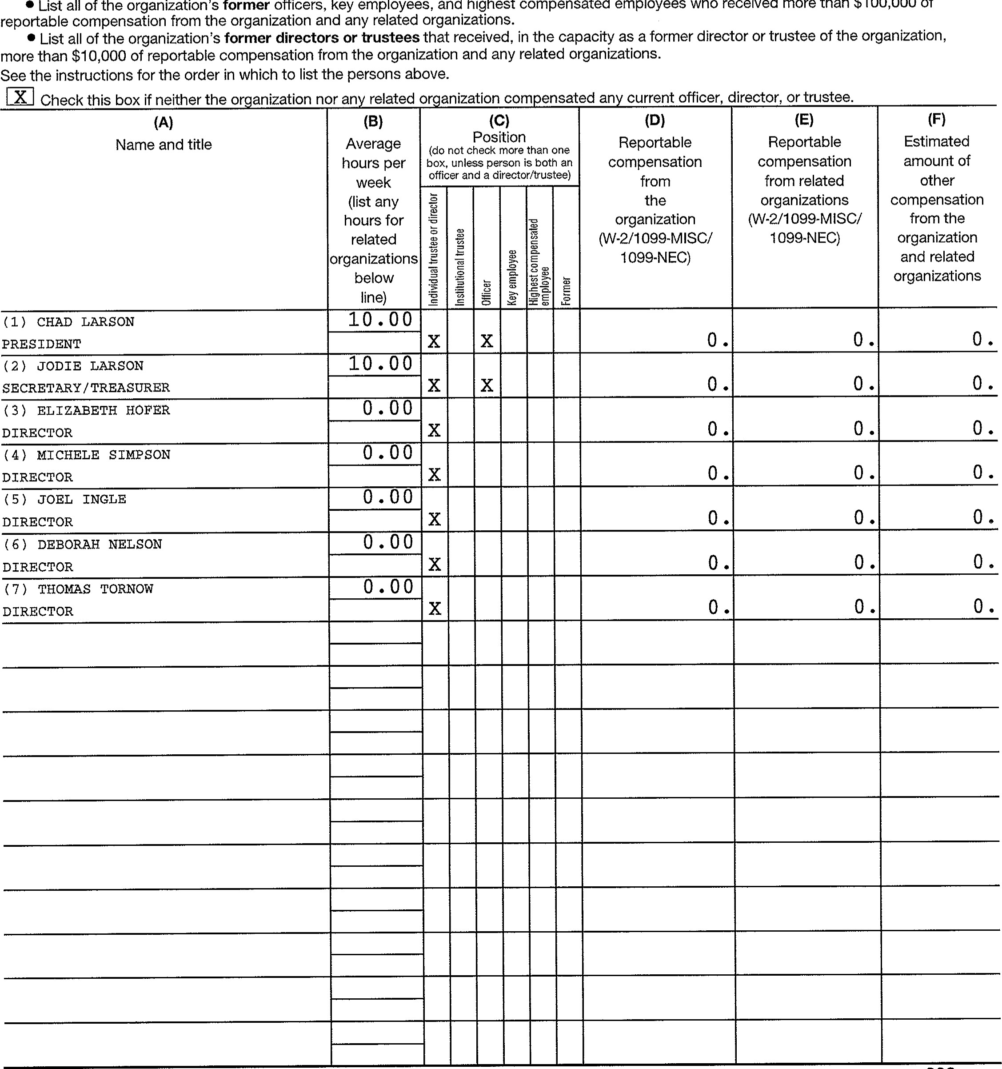
highest
compensated
employees
who
received
more
than
$100,000
of

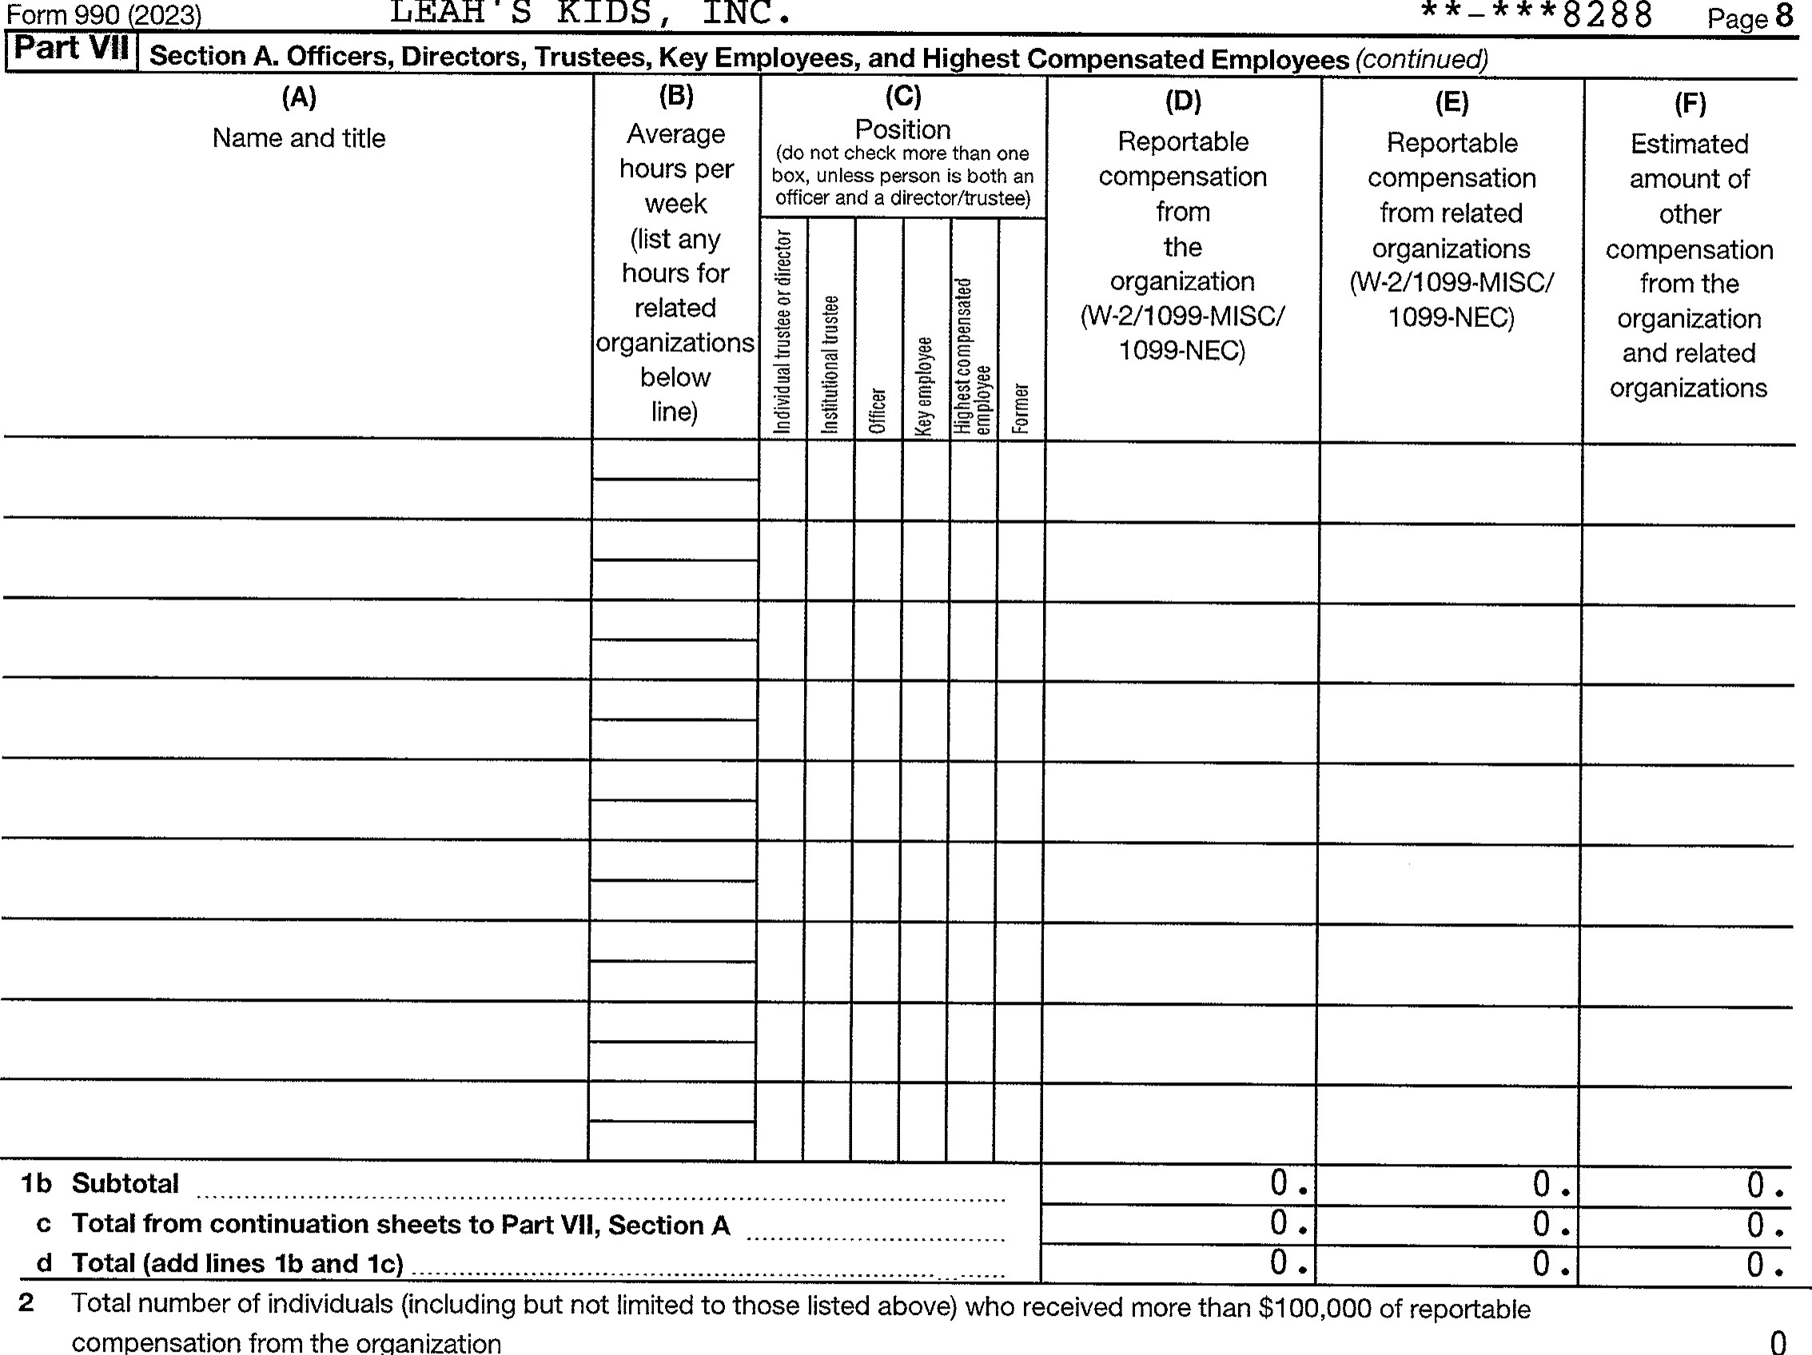
3  4  5 |  |  | Yes | No
3  4  5 | Did the organization list any former officer, director, trustee, key employee, or highest compensated employee on line la? If 'Yes, 'I complete Schedule J for such individual  For any individual listed on line la, is the sum of reportable compensation and other compensation from the organization and related organizations greater than $150,000'? If "Yes, complete Schedule J for such individual  Did any person listed on line la receive or accrue compensation from any unrelated organization or individual for services rendered to the or anization? If "Yes, complete Schedule J for such person | 3 |  | x
3  4  5 |  | 4 |  | x
3  4  5 |  | 5 |  | x

Section B. Independent Contractors

1 Complete this table for your five highest compensated independent contractors that received more than $100,000 of compensation from the or anization. Re ort com ensation for the calendar ear endin with or within the or anization's tax ear.
 | (A)  Name and business address NONE | (B)  Description of services | (C)  Compensation
2 | Total number of independent contractors (including but not limited to those listed above) who received more than  $100,000 of com ensation from the or anization
Form 990 (2023)
332008 12-21-23
^{I} S Page 9

Statement of Revenue
Check if Schedule O contains a response or note to any line in this Part Vlll
Total revenue Related or exempt Unrelated Revenue excluded function revenue business revenue from tax under
sections 512 - 514
1 a Federated campaigns la b Membership dues 1b c Fundraising events lc d Related organizations Id e Government grants (contributions) le f All other contributions, gifts, grants, and similar amounts not included above If 138 , 504 .
g Noncash contributions included in lines la-IT h Total. Add lines la-lf 138 , 504
Business Code
o
b
c d
o f All other program service revenue

Total. Add lines 2a2f
- Investment income (including dividends, interest, and other similar amounts) 58 . 58 .
- Income from investment of tax-exempt bond proceeds
- Royalties
(i) Real (ii) Personal
- a Gross rents b Less: rental expenses 6b c Rental income or (loss) 6c d Net rental income or (loss) .
- a Gross amount from sales of (i) Securities (ii) Other assets other than inventory 7a b Less: cost or other basis
3 and sales expenses 7b
c Gain or (loss) d Net gain or (loss)
8 a Gross income from fundraising events (not including $ of
contributions reported on line 1 c). See
Part IV, line 18 b Less: direct expenses c Net income or (loss) from fundraising events
Gross income from gaming activities. See
Part IV, line 19 9a b Less: direct expenses 9b c Net income or (loss) from gaming activities
10 a Gross sales of inventory, less returns
and allowances IOa b Less: cost of goods sold 10b
c Net income or loss from sales of invento
Business Code
b
c d At other revenue e Total. Add lines 1 la-I Id
12 Total revenue. See instructions 138 , 562 0 . o . 58 .
332009 12-21-23
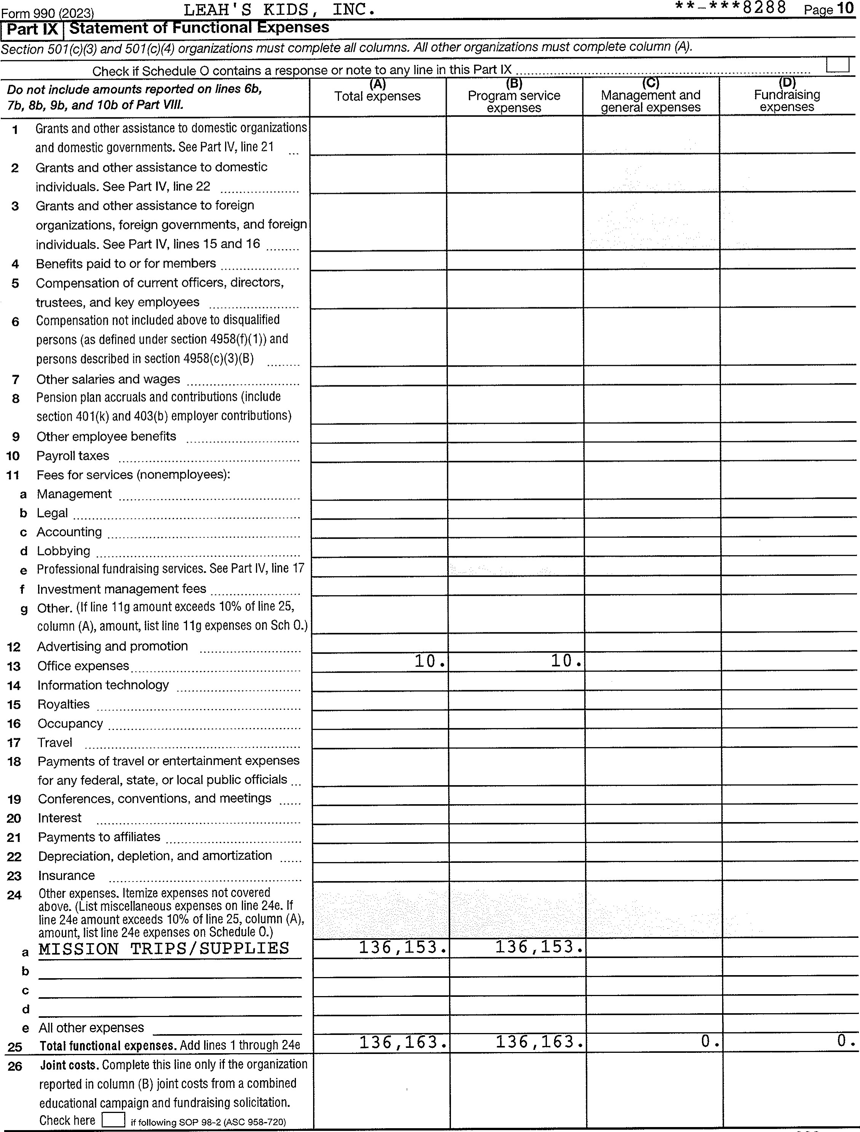
332010
12-21-23
Form
990
(2023)

 Pa e ll
Part X |  | Balance Sheet
 |  | Check if Schedule O contains a response or note to any line in this Part X
 |  |  |  |  |  |  |  | (A)  Beginning of year |  | (B)  End of year
v) | 1  2  3  4  5  6  7  8  9 iOa  b  11  12  13  14  15  16 |  | Cash - non-interest-bearing  Savings and temporary cash investments |  |  |  |  | 83 , 279 | 1 | 85 , 678
v) |  |  |  |  |  |  |  |  | 2
v) |  |  | Pledges and grants receivable, net  Accounts receivable, net  Loans and other receivables from any current or trustee, key employee, creator or founder, controlled entity or family member of any of these Loans and other receivables from other disqualified under section  and persons described  Notes and loans receivable, net  Inventories for sale or use  Prepaid expenses and deferred charges  Land, buildings, and equipment: cost or other basis. Complete Part VI of Schedule D Less: accumulated depreciation  Investments publicly traded securities  Investments other securities. See Part IV, line 1  Investments - program-related. See Part IV, line Intangible assets  Other assets. See Part IV, line 1 1  Total assets. Add lines 1 throu h 15 must e ual | former substantial persons  in  IOa | officer, director, contributor, or 35%  persons (as defined section 4958(c)(3)(B) |  |  |  | 3  4
 |  |  |  |  |  |  |  |  | 5
 |  |  |  |  |  |  |  |  | 6
 |  |  |  |  |  |  |  |  | 7
 |  |  |  |  |  |  |  |  | 8
 |  |  |  |  |  |  |  | 28 , 500 | 9 | 28 , 500
 |  |  |  |  |  |  |  |  | IOC
v) |  |  |  | 10b |  |  |  |  | IOC
v) |  |  |  | 1  1 1  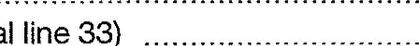 |  |  |  |  | 11
 |  |  |  |  |  |  |  |  | 12
 |  |  |  |  |  |  |  |  | 13
 |  |  |  |  |  |  |  |  | 14
 |  |  |  |  |  |  |  |  | 15
 |  |  |  |  |  |  |  | 111 , 779 . | 16 | 114 , 17 8
 | 17  18  19  20  21  22  23  24  25  26 |  | Accounts payable and accrued expenses  Grants payable  Deferred revenue  Tax-exempt bond liabilities  Escrow or custodial account liability. Complete Part IV of Schedule D Loans and other payables to any current or former officer, director, trustee, key employee, creator or founder, substantial contributor, or 35% controlled entity or family member of any of these persons  Secured mortgages and notes payable to unrelated third parties  Unsecured notes and loans payable to unrelated third parties  Other liabilities (including federal income tax, payables to related third parties, and other liabilities not included on lines 1724). Complete Part X of Schedule D  Total liabilities- Add lines 17 throu h 25 |  |  |  |  |  | 17
 |  |  |  |  |  |  |  |  | 18
 |  |  |  |  |  |  |  |  | 19
 |  |  |  |  |  |  |  |  | 20
 |  |  |  |  |  |  |  |  | 21
 |  |  |  |  |  |  |  | 
 |  |  |  |  |  |  |  |  | 23
 |  |  |  |  |  |  |  |  | 24
 |  |  |  |  |  |  |  |  | 25
 |  |  |  |  |  |  |  |  | 26 | o .
z | 27  28  29  30  31  32  33 |  | Organizations that follow FASB ASC 958, check here and complete lines 27, 28, 32, and 33. Net assets without donor restrictions  Net assets with donor restrictions  Organizations that do not follow FASB ASC 958, check here and complete lines 29 through 33.  Capital stock or trust principal, or current funds  Paid-in or capital surplus, or land, building, or equipment fund  Retained earnings, endowment, accumulated income, or other  Total net assets or fund balances  Total liabilities and net assets/fund balances |  |  |  | funds |  | 27
 |  |  |  |  |  |  |  |  | 28
 |  |  |  |  |  |  |  |   0 . | 29 | 0 .
 |  |  |  |  |  |  |  | 0 . | 30 | o .
 |  |  |  |  |  |  |  | 111 , 779 . | 31 | 114 , 178
 |  |  |  |  |  |  |  | 111 , 779 . | 32 | 114 17 8
 |  |  |  |  |  |  |  | 111 , 779 . | 33 | 17 8
Form 990 (2023)
- 12-21-23
 Pa e 12
Part XI | Reconciliation of Net Assets
Check if Schedule O contains a response or note to any line in this Part Xl
1 Total revenue (must equal Part Vlll, column (A), line 12) 1 | 138 , 562
2 Total expenses (must equal Part IX, column (A), line 25) 2 | 136 , 163
3 Revenue less expenses. Subtract line 2 from line 1 3 | 2 , 399
- Net assets or fund balances at beginning of year (must equal Part X, line 32, column (A)) 4  - Net unrealized gains (losses) on investments 5  - Donated services and use of facilities 6  - Investment expenses 7  - Prior period adjustments 8 | 111 , 779
- Other changes in net assets or fund balances (explain on Schedule O) 9  - Net assets or fund balances at end of year. Combine lines 3 through 9 (must equal Part X, line 32, | o .
column B 10  Part XII Financial Statements and Reporting  Check if Schedule O contains a res onse or note to an line in this Part XII | 114 , 178
1 Accounting method used to prepare the Form 990: Cash Accrual Other  If the organization changed its method of accounting from a prior year or checked "Other, explain on Schedule O. | Yes | No
2a Were the organization's financial statements compiled or reviewed by an independent accountant?  If "Yes, check a box below to indicate whether the financial statements for the year were compiled or reviewed on a separate basis, consolidated basis, or both:  Separate basis Consolidated basis Both consolidated and separate basis |  | x
b Were the organization's financial statements audited by an independent accountant?  If "Yes," check a box below to indicate whether the financial statements for the year were audited on a separate basis, consolidated basis, or both:  Separate basis Consolidated basis Both consolidated and separate basis c If "Yes" to line 2a or 2b, does the organization have a committee that assumes responsibility for oversight of the audit, | 2b | x
review, or compilation of its financial statements and selection of an independent accountant?  If the organization changed either its oversight process or selection process during the tax year, explain on Schedule O.  3a As a result of a federal award, was the organization required to undergo an audit or audits as set forth in the | 2c
Uniform Guidance, 2 C.F.R. Part 200, Subpart F?  b If "Yes," did the organization undergo the required audit or audits? If the organization did not undergo the required audit |  | x
or audits, ex lain wh on Schedule O and describe an ste s taken to under o such audits | 3b
Form 990 (2023)
- 12-21-23
SCHEDULE A  (Form 990)  Department of the Treasury  Internal Revenue Service |  | Public Charity Status and Public Support  Complete if the organization is a section 501(c)(3) organization or a section 4947(a)(1) nonexempt charitable trust.  Attach to Form 990 or Form 990-EZ.  Go to www.irs.gov/Form990 for instructions and the latest information. |  | OMB No. 1545-0047
2023
Open to Public Inspection
Name of the organization  LEAH'S KIDS, INC. |  |  | Employer identification number  
Part l | Reason for Public Charity Status. (All organizations must complete this part.) see instructions.
The organization is not a private foundation because it is: (For lines 1 through 12, check only one box.)

A church, convention of churches, or association of churches described in section 170(b)(1)(A)(i).
2 A school described in section  (Attach Schedule E (Form 990).)
3A hospital or a cooperative hospital service organization described in section 170(b)(1)(A)(iii).
- A medical research organization operated in conjunction with a hospital described in section  Enter the hospital's name, city, and state:

- An organization operated for the benefit of a college or university owned or operated by a governmental unit described in section  (Complete Part ll.)
- A federal, state, or local government or governmental unit described in section
- An organization that normally receives a substantial part of its support from a governmental unit or from the general public described in section  (Complete Part ll.)
- A community trust described in section 170(b)(1)(A)(vi). (Complete Part ll.)
- An agricultural research organization described in section 170(b)(1)(A)(ix) operated in conjunction with a land-grant college or university or a non-land-grant college of agriculture (see instructions). Enter the name, city, and state of the college or university:

- An organization that normally receives (1) more than 33 1/3% of its support from contributions, membership fees, and gross receipts from activities related to its exempt functions, subject to certain exceptions; and (2) no more than 33 1/3% of its support from gross investment income and unrelated business taxable income (less section 51 1 tax) from businesses acquired by the organization after June 30, 1975.
See section 509(a)(2). (Complete Part Ill.)
Il An organization organized and operated exclusively to test for public safety. See section
12 An organization organized and operated exclusively for the benefit of, to perform the functions of, or to carry out the purposes of one or
more publicly supported organizations described in section 509(a)(1) or section 509(a)(2). See section  Check the box on lines 12a through 12d that describes the type of supporting organization and complete lines 12e, 12f, and 12g.
Type l. A supporting organization operated, supervised, or controlled by its supported organization(s), typically by giving the supported organization(s) the power to regularly appoint or elect a majority of the directors or trustees of the supporting organization. You must complete Part IV, Sections A and B.
Type ll. A supporting organization supervised or controlled in connection with its supported organization(s), by having control or management of the supporting organization vested in the same persons that control or manage the supported organization(s). You must complete Part IV, Sections A and C.
c Type Ill functionally integrated. A supporting organization operated in connection with, and functionally integrated with, its supported organization(s) (see instructions). You must complete Part IV, Sections A, D, and E.
Type Ill non-functionally integrated. A supporting organization operated in connection with its supported organization(s) that is not functionally integrated. The organization generally must satisfy a distribution requirement and an attentiveness requirement (see instructions). You must complete Part IV, Sections A and D, and Part V.
Check this box if the organization received a written determination from the IRS that it is a Type I, Type Il, Type Ill functionally integrated, or Type Ill non-functionally integrated supporting organization.
f Enter the number of supported organizations g Provide the following information about the supported organization(s).
(i) Name of supported organization | (ii) EIN | (iii) Type of organization (described on lines 1-10 above see instructions | (iv) Is the organization listed your governing document? |  | (v) Amount of monetary support (see instructions) | (vi) Amount of other support (see instructions)
(i) Name of supported organization | (ii) EIN |  | Yes | No | (v) Amount of monetary support (see instructions) | (vi) Amount of other support (see instructions)
Total

LHA For Paperwork Reduction Act Notice, see the Instructions for Form 990 or 990-EZ 332021 12-21-23


Part Il | Support Schedule for Organizations Described in Sections 170(b)(1)(A)(iv) and 170(b)(1)(A)(vi)  (Complete only if you checked the box on line 5, 7, or 8 of Part I or if the organization failed to qualify under Part Ill. If the organization fails to qualify under the tests listed below, please complete Part Ill.)

Section A. Public Support
Calendar year (or fiscal year beginning in)  - Gifts, grants, contributions, and membership fees received. (Do not include any ^{n} unusual grants.  - Tax revenues levied for the organization's benefit and either paid to or expended on its behalf  - The value of services or facilities furnished by a governmental unit to the organization without charge  - Total. Add lines 1 through 3  - The portion of total contributions by each person (other than a governmental unit or publicly supported organization) included on line 1 that exceeds 2% of the amount shown on line 1 1, column (f)  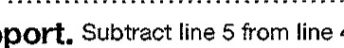 | a) 2019 | (b) 2020 | c 2021 | d) 2022 | e) 2023 | f) Total
 | 143 , 226 . | 181 , 472 . | 108 , 375 | 72 , 892 . | 137 , 173 . | 643 , 138
 | 143 , 226 . | 181 , 472 . | 108 , 375 | 72 , 892 . | 137 , 173 . | 643 , 138
 |  |  |  |  |  | 643 , 138
6 Public Su ort. Subtract line 5 from line 4.

Section B. Total Support
Calendar year (or fiscal year beginning in)  - Amounts from line 4  - Gross income from interest, dividends, payments received on securities loans, rents, royalties, and income from similar sources  - Net income from unrelated business activities, whether or not the business is regularly carried on  - Other income. Do not include gain or loss from the sale of capita!  assets (Explain in Part VI.)  1 1 Total support. Add lines 7 through 10  12 Gross receipts from related activities, | (a) 2019 | (b) 2020 | (c) 2021 | (d) 2022 | (e) 2023 |  | (f) Total
 | 143 , 226 . | 181 , 472 . | 108 , 375 . | 72 , 892 . | 137 , 173 . |  | 643 1 138
 |  | 5 . |  | 15 . | 58 . |  | 90 .
 |  |  |  |  |  |  | 643 , 228
 | etc. (see instructions) |  |  |  | 12 |  | 12 , 933
13 First 5 years. If the Form 990 is for the organization's first, second, third, fourth, or fifth tax year as a section 501 (c)(3) organization, check this box and stop here
Section C. Computation of Public Support Percentage
- Public support percentage for 2023 (line 6, column (f), divided by line 11, column (f))  - Public support percentage from 2022 Schedule A, Part Il, line 14 | 14 | 99 . 99 /
 | 15 | 100 . 00 /
16a 33 1/3% support test - 2023. If the organization did not check the box on line 13, and line 14 is 83 1/3% or more, check this box and stop hereu The organization qualifies as a publicly supported organization b 33 1/3% support test - 2022. If the organization did not check a box on line 13 or 16a, and line 15 is 33 1/3% or more, check this box and stop here. The organization qualifies as a publicly supported organization
17a 10% -facts-and-circumstances test - 2023, If the organization did not check a box on line 13, 16a, or 16b, and line 14 is 10% or more, and if the organization meets the facts-and-circumstances test, check this box and stop here. Explain in Part VI how the organization meets the facts-and-circumstances test. The organization qualifies as a publicly supported organization b 10% -facts-and-circumstances test - 2022. If the organization did not check a box on line 13, 16a, 16b, or 17a, and line 15 is 10% or more, and if the organization meets the facts-and-circumstances test, check this box and stop here. Explain in Part VI how the organization meets the facts-and-circumstances test. The organization qualifies as a publicly supported organization
18 Private foundation. If the organization did not check a box on line 13, 16a, 16b, 17a, or 17b, check this box and see instructions _
Schedule A (Form 990) 2023
332022 12-21-23

Part Ill | upport chedule for rganizations Described in ection 509 a  (Complete only if you checked the box on line 10 of Part I or if the organization failed qualify under the tests listed below, please complete Part ll.) | 2  to | qualify under Part Il. If the organization fails to

Section A. Public Support
Calendar year (or fiscal year beginning in)  - Gifts, grants, contributions, and membership fees received. (Do not include any "unusual grants. ^{l}')  - Gross receipts from admissions, merchandise sold or services performed, or facilities furnished in any activity that is related to the organization's tax-exempt purpose  - Gross receipts from activities that are not an unrelated trade or business under section 513  - Tax revenues levied for the organization's benefit and either paid to or expended on its behalf  - The value of services or facilities furnished by a governmental unit to the organization without charge  - Total. Add lines 1 through 5  7a Amounts included on lines 1, 2, and  3 received from disqualified persons  - Amounts included on lines 2 and 3 received from other than disqualified persons that exceed the greater of $5,000 or 1% of the amount on line 13 for the year  - Add lines 7a and 7b | (a) 2019 | b) 2020 |  | c) 2021 | d) 2022 | (e) 2023 | (f) Total
8 Public Su ort. Subtract line 70 from line 6.

Section B. Total Support
Calendar year (or fiscal year beginning in)  9 Amounts from line 6  10a Gross income from interest, dividends, payments received on securities loans, rents, royalties, and income from similar sources b Unrelated business taxable income  (less section 51 1 taxes) from businesses acquired after June 30, 1975  c Add lines 10a and 10b  1 1 Net income from unrelated business activities not included on line 10b, whether or not the business is regularfy carried on  - Other income. Do not include gain or loss from the sale of capital assets (Explain in Part VI.)  - Total support. (Add lines 9, 11, and 12.) | (a) 2019 | (b) 2020 | (c) 2021 | (d) 2022 | (e) 2023 | (f) Total
14 First 5 years. If the Form 990 is for the organization's first, second, third, fourth, or fifth tax year as a section 501 (c)(3) organization, check this box and stop here

Section C. Computation of Public Support Percentage
- Public support percentage for 2023 (line 8, column (f), divided by line 13, column (f))  - Public su ort ercenta e from 2022 Schedule A, Part Ill, line 15 | 15
 | 16

Section D. Computation of Investment Income Percentage
- Investment income percentage for 2023 (line IOC, column (f), divided by line 13, column (f))  - Investment income percentage from 2022 Schedule A, Part Ill, line 17 | 17
 | 18
19a 33 1/3% support tests - 2023. If the organization did not check the box on line 14, and line 15 is more than 33 1/3% , and line 17 is not more than 33 1/3% , check this box andstop here. The organization qualifies as a publicly supported organization b 33 1/3% support tests - 2022. If the organization did not check a box on line 14 or line 19a, and line 16 is more than 33 1/3%, and line 18 is not more than 33 1/3% , check this box and stop here. The organization qualifies as a publicly supported organization
20 Private foundation. If the oraanization did not check a box on line 14, 19a, or 19b, check this box and see instructions _
332023
^{I} S  pa
Part V | Supporting Organizations  (Complete only if you checked a box on line 12 of Part l. If you checked box 12a, Part I, complete Sections A and B. If you checked box 12b, Part l, complete Sections A and C. If you checked box 12c, Part l, complete Sections A, D, and E. If you checked box 12d, Part l, complete Sections A and D, and complete Part V.)

Section A All Supporting Organizations
- Are all of the organization's supported organizations listed by name in the organization's governing documents? If "No, describe in Part VI how the supported organizations are designated. If designated by class or purpose, describe the designation. If historic and continuing relationship, explain,  - Did the organization have any supported organization that does not have an IRS determination of status under section 509(a)(1) or (2)? If "Yes, explain in part VI how the organization determined that the supported organization was described in section 509(a)(1) or (2).  3a Did the organization have a supported organization described in section 501 (c)(4), (5), or (6)? If 'Yes, " answer lines 3b and 3c below.  - Did the organization confirm that each supported organization qualified under section 501 (c)(4), (5), or (6) and satisfied the public support tests under section 509(a)(2)? If "Yes, describe in Part VI when and how the organization made the determination.  - Did the organization ensure that all support to such organizations was used exclusively for section 170(c)(2)(B) purposes? If "Yes, explain in Part VI what controls the organization put in place to ensure such use.  4a Was any supported organization not organized in the United States ("foreign supported organization")? If ^{ll} Yes, and if you checked box 12a or 12b in Part l, answer lines 4b and 4c below.  - Did the organization have ultimate control and discretion in deciding whether to make grants to the foreign supported organization? If "Yes, describe in Part VI how the organization had such control and discretion despite being controlled or supervised by or in connection with its supported organizations.  - Did the organization support any foreign supported organization that does not have an IRS determination under sections 501 (c)(3) and 509(a)(1) or (2)? If "Yes, " explain in Part VI what controls the organization used to ensure that all support to the foreign supported organization was used exclusively for section 170(c)(2)(B) purposes.  5a Did the organization add, substitute, or remove any supported organizations during the tax year? If "Yes, " answer lines 5b and 5c below (if applicable). Also, provide detail in Part VI, including (i) the names and EIN numbers of the supported organizations added, substituted, or removed; (ii) the reasons for each such action; (iii) the authority under the organization ^{I}s organizing document authorizing such action; and (iv) how the action was accomplished (such as by amendment to the organizing document).  - Type I or Type Il only, Was any added or substituted supported organization part of a class already designated in the organization's organizing document?  - Substitutions only. Was the substitution the result of an event beyond the organization's control?  - Did the organization provide support (whether in the form of grants or the provision of services or facilities) to anyone other than (i) its supported organizations, (ii) individuals that are part of the charitable class benefited by one or more of its supported organizations, or (iii) other supporting organizations that also support or benefit one or more of the filing organization's supported organizations? If "Yes, " provide detail in Part VI.  - Did the organization provide a grant, loan, compensation, or other similar payment to a substantial contributor (as defined in section 4958(c)(3)(C)), a family member of a substantial contributor, or a 35% controlled entity with regard to a substantial contributor? ff 'Yes, " complete Part I of Schedule L (Form 990),  - Did the organization make a loan to a disqualified person (as defined in section 4958) not described on line 7? If "Yes, ^{t}' complete Part I of Schedule L (Form 990).  9a Was the organization controlled directly or indirectly at any time during the tax year by one or more disqualified persons, as defined in section 4946 (other than foundation managers and organizations described in section 509(a)(1) or (2))? If "Yes, " provide detail in Part VI.  - Did one or more disqualified persons (as defined on line 9a) hold a controlling interest in any entity in which the supporting organization had an interest? If 'Yes, " provide detail in Part VI.  - Did a disqualified person (as defined on line 9a) have an ownership interest in, or derive any personal benefit from, assets in which the supporting organization also had an interest? If "Yes, " provide detail in Part VI.  10a Was the organization subject to the excess business holdings rules of section 4943 because of section 4943(f) (regarding certain Type Il supporting organizations, and all Type Ill non-functionally integrated supporting organizations)? If "Yes, " answer line 10b below.  b Did the organization have any excess business holdings in the tax year? (Use Schedule C, Form 4720, to determine whether the organization had excess business holdings) |  | Yes | No
 | 2
 | 3a
 | 3b
 | 4b
 | 4c
 | 5b
 | 6
 | 7
 | 8
 | 9b
 | IOa
 | 10b
332024

.  pa
Part IV | Supporting Organizations continued
11 Has the organization accepted a gift or contribution from any of the following persons?  - A person who directly or indirectly controls, either alone or together with persons described on lines 11b and 1 1 c below, the governing body of a supported organization?  - A family member of a person described on line 1 la above?  - A 35% controlled entity of a person described on line lla or 11b above?lf "Yes" to line 1 la, 11b, or llc, provide detail in Part VI. |  |  | Yes | No
 |  | lla
 |  | 11b
 |  | 1 lc

Section B. Type I Supporting Organizations
1  2 | Did the governing body, members of the governing body, officers acting in their official capacity, or membership of one or more supported organizations have the power to regularly appoint or elect at least a majority of the organization's officers, directors, or trustees at all times during the tax year? If "No, " describe in Part VI how the supported organization(s) effectively operated, supervised, or controlled the organization S activities. If the organization had more than one supported organization, describe how the powers to appoint and/or remove officers, directors, or trustees were allocated among the supported organizations and what conditions or restrictions, if any, applied to such powers during the tax year.  Did the organization operate for the benefit of any supported organization other than the supported organization(s) that operated, supervised, or controlled the supporting organization? If "Yes, explain in Part VI how providing such benefit carried out the purposes of the supported organization(s) that operated, supervised, or controlled the supporting organization. |  | Yes | No
1  2 |  | 1
1  2 |  | 2

Section C. Type Il Supporting Organizations
1 | Were a majority of the organization's directors or trustees during the tax year also a majority of the directors or trustees of each of the organization's supported organization(s)? If ^{II}NO, describe in Part VI how control or management of the supporting organization was vested in the same persons that controlled or managed the supported organization(s). |  | Yes | No
1 |  | 1

Section D. All Type Ill Supporting Organizations
1  2  3 | Did the organization provide to each of its supported organizations, by the last day of the fifth month of the organization's tax year, (i) a written notice describing the type and amount of support provided during the prior tax year, (ii) a copy of the Form 990 that was most recently filed as of the date of notification, and (iii) copies of the organization's goveming documents in effect on the date of notification, to the extent not previously provided? Were any of the organization's officers, directors, or trustees either (i) appointed or elected by the supported organization(s) or (ii) serving on the governing body of a supported organization? If ^{II}NO, " explain in Part VI how the organization maintained a close and continuous working relationship with the supported organization(s). By reason of the relationship described on line 2, above, did the organization's supported organizations have a significant voice in the organization's investment policies and in directing the use of the organization's income or assets at all times during the tax year? If "Yes, describe in Part VI the role the organization 's supported organizations played in this regard. |  | Yes | No
1  2  3 |  | 2
1  2  3 |  | 3

Section E. Type Ill Functionally Integrated Supporting Organizations

1 Check the box next to the method that the organization used to satisfy the Integra/ Part Test during the yea(see instructions).

aThe organization satisfied the Activities Test. Complete line 2 below.
bThe organization is the parent of each of its supported organizations. Complete line 3 below.
cThe organization supported a governmental entity. Describe in Part VI how you supported a governmental entity (see instructions).
2 Activities Test. Answer lines 2a and 2b below.  - Did substantially all of the organization's activities during the tax year directly further the exempt purposes of the supported organization(s) to which the organization was responsive? If 'Yes, then in Part VI identify those supported organizations and explain how these activities directly furthered their exempt purposes, how the organization was responsive to those supported organizations, and how the organization determined that these activities constituted substantially all of its activities.  - Did the activities described on line 2a, above, constitute activities that, but for the organization's involvement, one or more of the organization's supported organization(s) would have been engaged in? If "Yes, " explain in Part VI the reasons for the organization S position that its supported organization(s) would have engaged in these activities but for the organization 's involvement.  3 Parent of Supported Organizations. Answer lines 3a and 3b below.  - Did the organization have the power to regularly appoint or elect a majority of the officers, directors, or trustees of each of the supported organizations? If "Yes or "No provide details in Part VI.  - Did the organization exercise a substantial degree of direction over the policies, programs, and activities of each of its supported organizations? If "Yes, " describe in Part VI the role played by the organization in this regard |  | Yes | No
 | 2b
 | 3b
332025
 Pa
Part V |  | Type Ill Non-Functionally Integrated 509(a)(3) Supporting Organizations
1 |  | Check here if the organization satisfied the Integral Part Test as a qualifying trust on Nov. 20, 1970 (explain in Part VI). See instructions.
All other Type Ill non-functionally inte rated supportin or anizations must complete Sections A throu h E.
Section A - Adjusted Net Income |  |  |  |  | (A) Prior Year | (B) Current Year  (optional)
1 Net short-term ca ital ain |  |  |  | 1
2 Recoveries of rior- ear distributions |  |  |  | 2
3 Other ross income see instructions |  |  |  | 3
4 Add lines 1 throu h 3. |  |  |  | 4
5 De reciation and de letion |  |  |  | 5
6 Portion of operating expenses paid or incurred for production or collection of gross income or for management, conservation, or maintenance of ro e held for roduction of income see instructions |  |  |  | 6
7 Other ex enses see instructions |  |  |  | 7
8 Ad-usted Net Income subtract lines 5, 6, and 7 from line 4 |  |  |  | 8
Section B Minimum Asset Amount |  |  |  |  | (A) Prior Year | (B) Current Year  (optional)
1 Aggregate fair market value of all non-exempt-use assets (see instructions for short tax ear or assets held for art of ear : |  |  |  |  | 
a Avera e monthl value of securities |  |  |  | la
b Avera e monthl cash balances |  |  |  | 1b
c Fair market value of other non-exem t-use assets |  |  |  | lc
d Total add lines la, 1b, and lc
e Discount claimed for blockage or other factors explain in detail in Part VI |  |  |  |  | 
2 Ac uisition indebtedness a |  |  | licable to non-exem t-use assets | 2
3 Subtract line 2 from line Id. |  |  |  | 3
4 Cash deemed held for exempt use. Enter 0.015 of line 3 (for greater amount, see instructions . |  |  |  | 4
5 Net value of non-exempt-use assets (subtract line 4 from line 3) |  |  |  | 5
6 Multiply line 5 by 0.035. |  |  |  | 6
7 Recoveries of prior-year distributions |  |  |  | 7
8 Minimum Asset Amount add line 7 to line 6 |  |  |  | 8
Section C - Distributable Amount |  |  |  |  |  | Current Year
1 Ad•usted net income for rior ear from Section A, line 8, column A |  |  |  | 1
2 Enter 0.85 of line 1. |  |  |  | 2 | 
3 Minimum asset amount for prior year (from Section B, line 8, column A) |  |  |  | 3  4 | 
4 Enter reater of line 2 or line 3. 5 Income tax imposed in prior year |  |  |  | 5 | 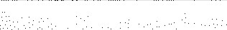
6 Distributable Amount, Subtract line 5 from line 4, unless subject to emer ency temporary reduction (see instructions). |  |  |  | 6 | 
7 |  | Check here if the current year is the organization's first as a nonåunctionally integrated Type Ill supporting organization (see
instructions).

Schedule A (Form 990) 2023
332026
pa
Part V |  | Type Ill Non-Functionally Integrated 509(a)(3) Supporting Organizations continued
Section D |  | - Distributions |  |  |  |  |  |  | Current Year
1 |  | Amounts paid to supported or anizations to accomplish exempt purposes |  |  |  |  |  | 1
2 or |  | Amounts paid to perform activity that directly furthers exempt purposes of supported anizations, in excess of income from activit |  |  |  |  |  | 2
3 |  | Administrative ex enses aid to accom lish exem t ur oses of su |  |  |  | orted or anizations |  | 3
4 |  | Amounts aid to ac uire exem t-use assets |  |  |  |  |  | 4
5 |  | Qualified set-aside amounts | rior IRS a | roval re uired -provide details in Part VI |  |  |  | 5
6 Other |  | distributions (describe in Part VI See instructions. |  |  |  |  |  | 6
7 Total |  | annual distributions. Add lines 1 throu h 6. |  |  |  |  |  | 7
8 |  | Distributions to attentive supported organizations to which the organization is responsive rovide details in Part VI). See instructions. |  |  |  |  |  | 8
9 |  | Distributable amount for 2023 from Section C, line 6 |  |  |  |  |  | 9
10 Line |  | 8 amount divided b line 9 amount |  |  |  |  |  | 10
Section E |  | - Distribution Allocations (see instructions) |  |  | Excess Distributions |  | (ii)  Underdistributions Pre-2023 |  | (iii)  Distributable  Amount for 2023
1 | Distributable amount for 2023 from Section C, line 6
2 | Underdistributions, if any, for years prior to 2023 (reasonable cause re uired - explain in Part VI . See instructions.
3 | Excess distributions car over, if an , to 2023
a | From 2018
b | From 2019
c | From 2020
d | From 2021
e | From 2022
f | Total of lines 3a throu h 3e
 | A lied to underdistributions of rior ears
h | Applied to 2023 distributable amount
 | Canyover from 2018 not applied (see instructions
j | Remainder. Subtract lines 3 , 3h, and 3i from line 3f.
4 | Distributions for 2023 from Section D, line 7:
a | A lied to underdistributions of rior ears
b | A | lied to 2023 distributable amount
c Remainder. Subtract lines 4a and 4b from line 4.
5 Remaining underdistributions for years prior to 2023, if any. Subtract lines 3g and 4a from line 2. For result greater than zero, explain in Part VI. See instructions.
6 Remaining underdistributions for 2023. Subtract lines 3h and 4b from line 1 . For result greater than zero, explain in
Part VI. See instructions.
7 Excess distributions carryover to 2024. Add lines .3j and 4c.
8 Breakdown of line 7:
a Excess from 2019
b Excess from 2020
c Excess from 2021
d Excess from 2022
e Excess from 2023
Schedule A (Form 990) 2023
332027 12-21-23

A _ *8288 pa
art | Supplemental Information. Provide the explanations required by Part Il, line 10; Part Il, line 17a or 17b; Part Ill, line 12; Part IV, Section A, lines 1, 2, 3b, 3c, 4b, 4c, 5a, 6, 9a, 9b, 9c, 1 la, 11b, and llc; Part IV, Section B, lines 1 and 2; Part IV, Section C, line 1; Part IV, Section D, lines 2 and 3; Part IV, Section E, lines lc, 2a, 2b, 3a, and 3b; Part V, line 1; Part V, Section B, line le; Part V, Section D, lines 5, 6, and 8; and Part V, Section E, lines 2, 5, and 6. Also complete this part for any additional information. (See instructions.)

332028 A 2023
Schedule B  (Form 990)  Department of the Treasury  Internal Revenue Service | Schedule of Contributors  Attach to Form 990, 990-EZ, or 990-PF.  Go to www.irs.gov/Form990 for the latest information. |  | OMB No. 1545-0047
 |  |  | 2023
Name of the organization  LEAH' S KIDS, INC . |  | Employer identification number  
Organization type (check one):
Filers of: | Section:
Form 990 or 990-EZ | 501 (c)( 3 ) (enter number) organization  4947(a)(1) nonexempt charitable trust not treated as a private foundation  527 political organization
Form 990-PF | 501 (c)(3) exempt private foundation
4947(a)(1) nonexempt charitable trust treated as a private foundation
501 (c)(3) taxable private foundation

Check if your organization is covered by the General Rule or a Special Rule.
Note: Only a section 501 (c)(7), (8), or (10) organization can check boxes for both the General Rule and a Special Rule. See instructions.

General Rule
For an organization filing Form 990, 990-EZ, or 990-PF that received, during the year, contributions totaling $5,000 or more (in money or property) from any one contributor. Complete Parts I and ll. See instructions for determining a contributor's total contributions.

Special Rules
X] For an organization described in section 501 (c)(3) filing Form 990 or 990-EZ that met the 33 1/3% support test of the regulations under sections 509(a)(1) and 170(b)(1)(A)(vi), that checked Schedule A (Form 990), Part Il, line 13, 16a, or 16b, and that received from any one contributor, during the year, total contributions of the greater of (1) $5,000; or (2) 2% of the amount on (i) Form 990, Part Vlll, line 1 h; or (ii) Form 990-EZ, line 1. Complete Parts I and ll.
For an organization described in section 501 (c)(7), (8), or (10) filing Form 990 or 990-EZ that received from any one contributor, during the year, total contributions of more than $1 ,OOO exclusively for religious, charitable, scientific, literary, or educational purposes, or for the prevention of cruelty to children or animals. Complete Parts I (entering "N/A" in column (b) instead of the contributor name and address), Il, and Ill.
For an organization described in section 501 (c)(7), (8), or (10) filing Form 990 or 990-EZ that received from any one contributor, during the year, contributions exclusively for religious, charitable, etc., purposes, but no such contributions totaled more than $1 ,OOO. If this box is checked, enter here the total contributions that were received during the year for an exclusively religious, charitable, etc., purpose. Don't complete any of the parts unless the General Rule applies to this organization because it received nonexclusively religious, charitable, etc., contributions totaling $5,000 or more during the year
Caution: An organization that isn't covered by the General Rule and/or the Special Rules doesn't file Schedule B (Form 990), but it must answer "No ^{ll} on Part IV, line 2, of its Form 990; or check the box on line H of its Form 990-EZ or on its Form 990-PF, Part l, line 2, to certify that it doesn't meet the filing requirements of Schedule B (Form 990).

For Paperwork Reduction Act Notice, see the instructions for Form 990, 990-EZ, or 990-PF. Schedule (Form 990)
I-HA 323451
Name of organization  LEAH'S KIDS, | INC. | Employer identification number  
Part I Contributors (see instructions). Use duplicate copies of Part I if additional space is needed.
(a) | (b)  Name, address, and ZIP + 4 | (c)  Total contributions | (d)  Type of contribution
1 | EYECARE CENTER OF MADISON  302 N HARTH AVE  IADISON, SD 57042 | 25 , 000 |   Person  Payroll  Noncash  (Complete Part Il for noncash contributions)
(a)  No. | (b)  Name, address, and ZIP + 4 | (c)  Total contributions | (d)  Type of contribution
2 | EMBRACE MADISON  305 CENTER ST E  MADISON, SD 57042 |   5,114 |   Person  Payroll  Noncash  (Complete Part Il for noncash contributions.)
No. | (b)  Name, address, and ZIP +4 | (c)  Total contributions | (d)  Type of contribution
 |  |  |   Person  Payroll  Noncash  (Complete Part Il for noncash contributions.)
(a) | (b)  Name, address, and ZIP +4 | (c)  Total contributions | (d)  Type of contribution
 |  |  |   Person  Payroll  Noncash  (Complete Part Il for noncash contributions.)
(a)  No. | (b)  Name, address, and ZIP +4 | (c)  Total contributions | (d)  Type of contribution
 |  |  |   Person  Payroll  Noncash  (Complete Part Il for noncash contributions.)
(a) | (b)  Name, address, and ZIP + 4 | (c)  Total contributions | (d)  Type of contribution

Person
Payroll
Noncash
(Complete Part Il for noncash contributions.)
323452

Name of organization  LEAH'S KIDS, | INC. | Employer identification number  
Part Il Noncash Property (see instructions). Use duplicate copies of Part Il if additional space is needed.
(a)  No.  from  Part I | (b)  Description of noncash property given | (c)  FMV (or estimate) (See instructions.) | (d)  Date received
 | 
(a)  from  Part I | (b)  Description of noncash property given | (c)  FMV (or estimate) (See instructions.) | (d)  Date received
 |  | 
(a)  No.  from  Part I | (b)  Description of noncash property given | (c)  FMV (or estimate) (See instructions.) | (d)  Date received
 | 
(a)  No.  from  Part I | (b)  Description of noncash property given | (c)  FMV (or estimate) (See instructions.) | (d)  Date received
 |  | 
(a)  from  Part I | (b)  Description of noncash property given | (c)  FMV (or estimate) (See instructions) | (d)  Date received
 | 
(a)  No.  from  Part I | (b)  Description of noncash property given | (c)  FMV (or estimate) (See instructions.) | (d)  Date received
323453
Name of organization  LEAH'S KIDS, INC. |  |  | Employer identification number  
 | art | Exclusively religious, charitable, etc., contributions to organizations described in section 501(c)(7), (8), or (10) that total more than $1,000 for the year
from any one contributor. Complete columns (a) through (e) and the following line entry. For organizations completing Part Ill, enter the total of exclusively religious, charitable, etc., contributions of $1 ,OOO or less for the year. (Enter this info. once.) $ Use duplicate copies of Part Ill if additional space is needed.
from  Part I | (b) Purpose of gift | (c) Use of gift |  | (d) Description of how gift is held
 |  |  |  | 
(e) Transfer of gift
Transferee's name, address, and ZIP + 4 Relationshi of transferor to transferee
 |  |  | 
(a) No.  from Part I | (b) Purpose of gift | (c) Use of gift |  | (d) Description of how gift is held
 |  |  |  | 
(e) Transfer of gift
Transferee's name, address, and ZIP + 4 Relationship of transferor to transferee
 |  |  | 
from Part | (b) Purpose of gift | (c) Use of gift |  | (d) Description of how gift is held
 |  |  |  | 
(e) Transfer of gift
Transferee's name, address, and ZIP + 4 Relationship of transferor to transferee
 |  |  | 
(a) No.  from Part I | (b) Purpose of gift | (c) Use of gift |  | (d) Description of how gift is held
 |  |  |  | 
(e) Transfer of gift
Transferee's name, address, and ZIP + 4 Relationship of transferor to transferee
 |  |  | 
323454
SCHEDULE O  (Form 990)  Department of the Treasury  Internal Revenue Service | Supplemental Information to Form 990 or 990-EZ  Complete to provide information for responses to specific questions on Form 990 or 990-EZ or to provide any additional information. Attach to Form 990 or Form 990-EZ.  Go to www.irs. ov/Form990 for the latest information. |  | OMB No. 1545-0047
2023
Open to Public Inspection
Name of the organization  LEAH'S KIDS, INc. |  | Employer identification number  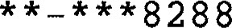
FORM 990, PART 1, LINE 1, DESCRIPTION OF ORGANIZATION MISSION:
CLOTHES , FOOD, AND EDUCATION.
FORM 990, PART VI, SECTION A, LINE | 2 :
TWO OF THE OFFICERS ARE MARRIED.
FORM 990, PART VI, SECTION B, LINE | 11B:
THE PRESIDENT REVIEWS THE 990 IN DETAIL. |  | AFTER HIS REVIEW, THE 990 IS
PROVIDED TO EACH BOARD MEMBER. WHETHER PRESENTED IN A BOARD MEETING OR

NOT, THE 990 IS NOT FILED UNTIL EACH BOARD MEMBER HAS BEEN GIVEN A COPY OF
IT AND HAS BEEN GIVEN AMPLE TIME TO REVIEW IT.

FORM 990, PART VI, SECTION B, LINE 12C:

THE CONFLICT OF INTEREST POLICY COVERS BOARD MEMBERS AND OFFICERS. A

REQUEST IS MADE ANNUALLY FOR ALL BOARD MEMBERS TO DISCLOSE ANY POTENTIAL

CONFILICT OF INTEREST. THE BOARD MAKES A DETERMINATION OF WHETHER THERE IS
A CONFLICT OF INTEREST AND IF SO, IMPLEMENTS THE PROCEDURE FOR EVALUATING

THE ISSUE OR TRANSACTION INVOLVED .

FORM 990, PART VI, SECTION C, LINE AVAILABLE AT WWW.LEAHSKIDS , ORG.

FORM 990, PART VI, SECTION C, LINE
AVAILABLE AT WWW.LEAHSKIDS . ORG.

For Paperwork Reduction Act Notice, see the Instructions for Form 990 or 990-EZ. O 2023
LHA 332211 11-14-23

